1. Install Power BI Desktop and share the final screenshot of the report view page which appears when power desktop starts.

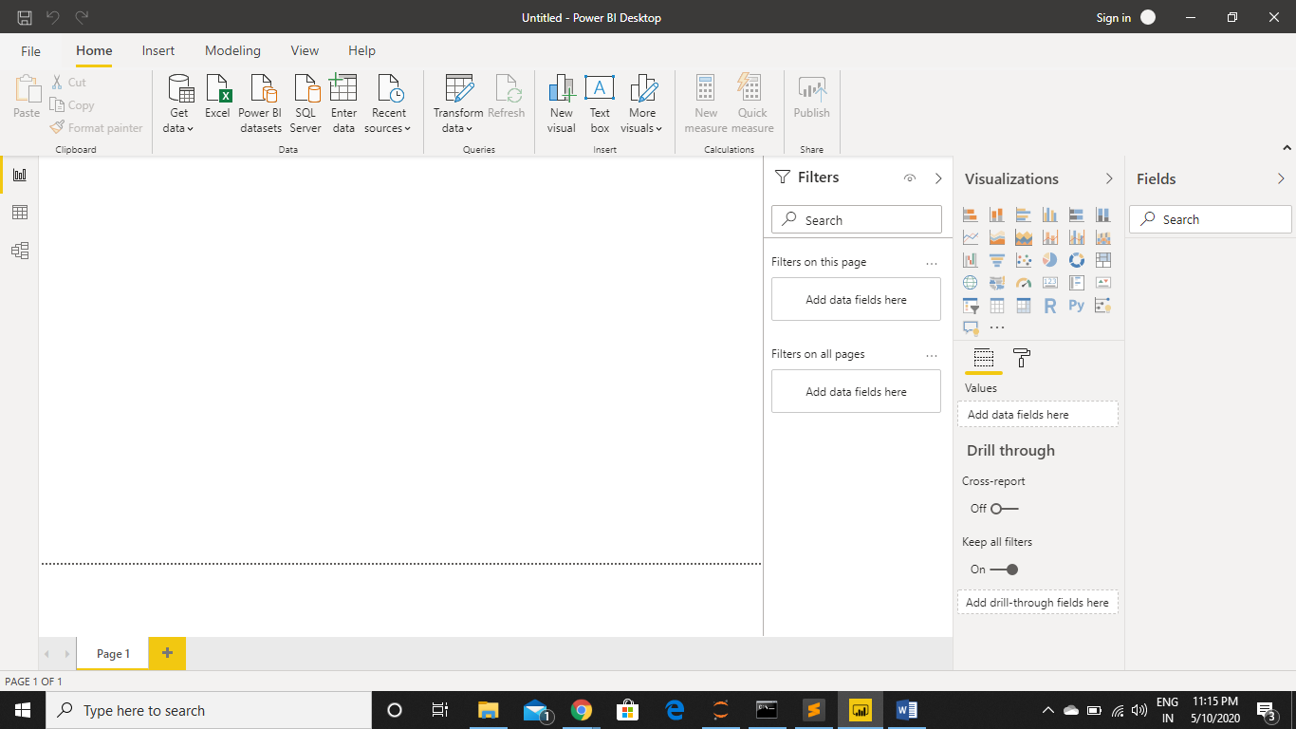

• Prepare a document and with the following screenshot − Report View − Data View − Model View − Power Query Editor − Advance Editor

Report View



Data View –

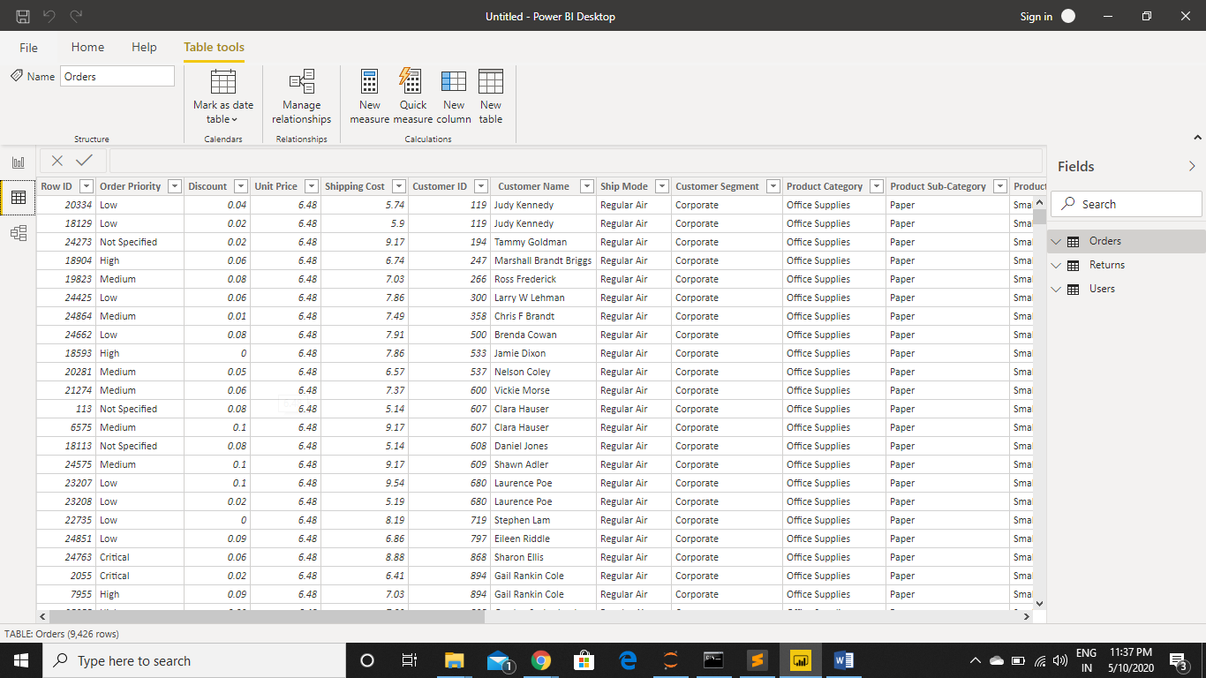

Model View –

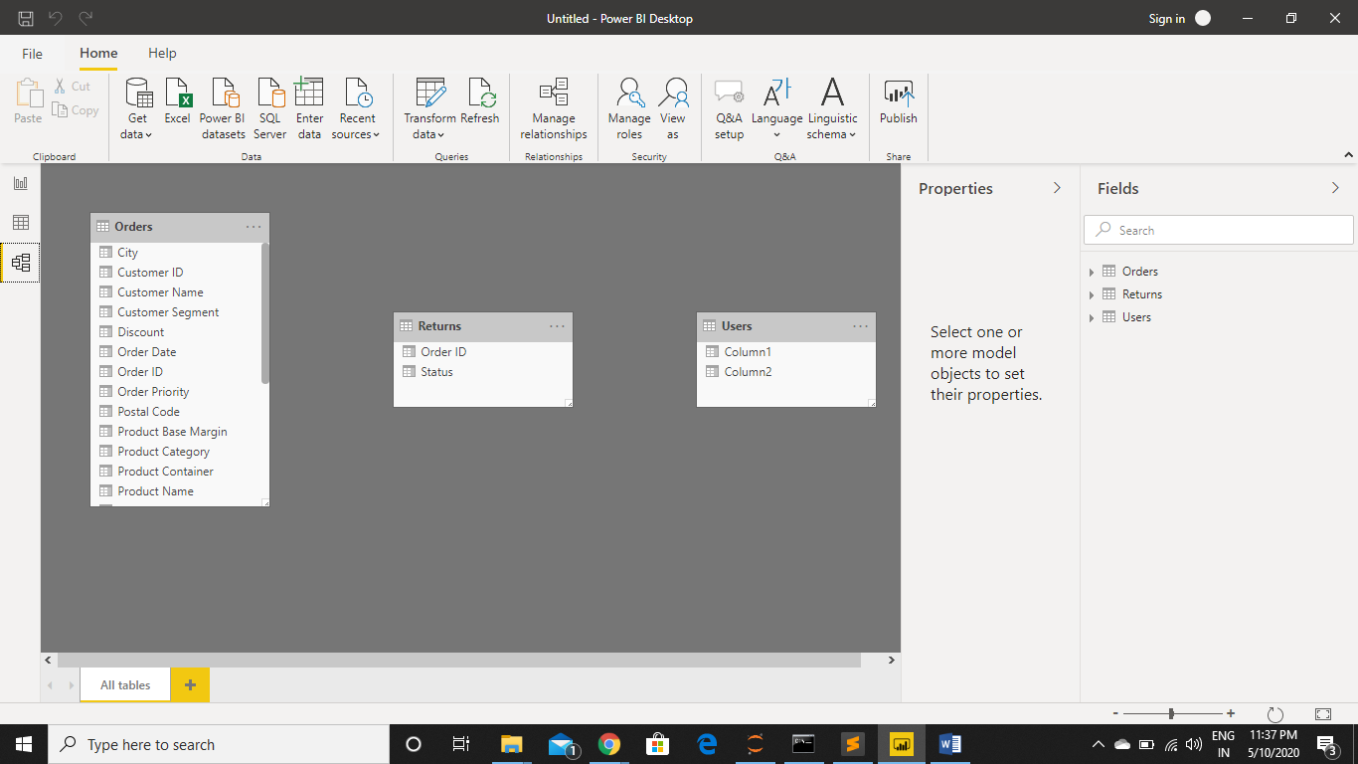

Power Query Editor –

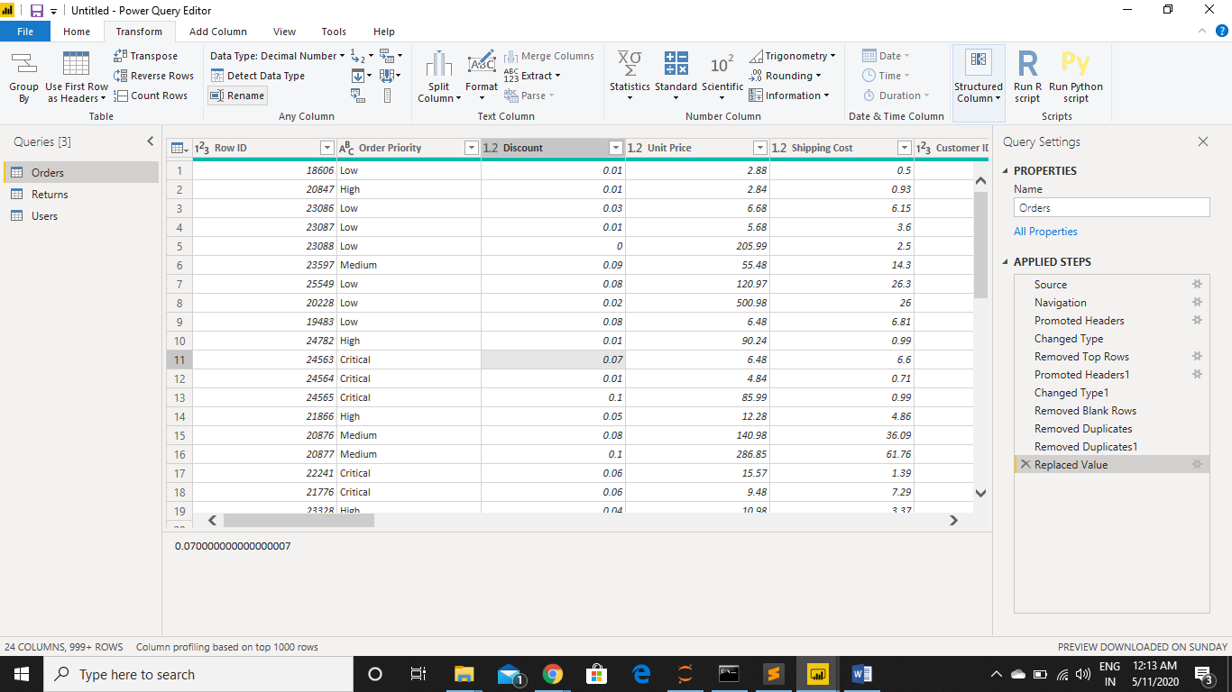

Advance Editor

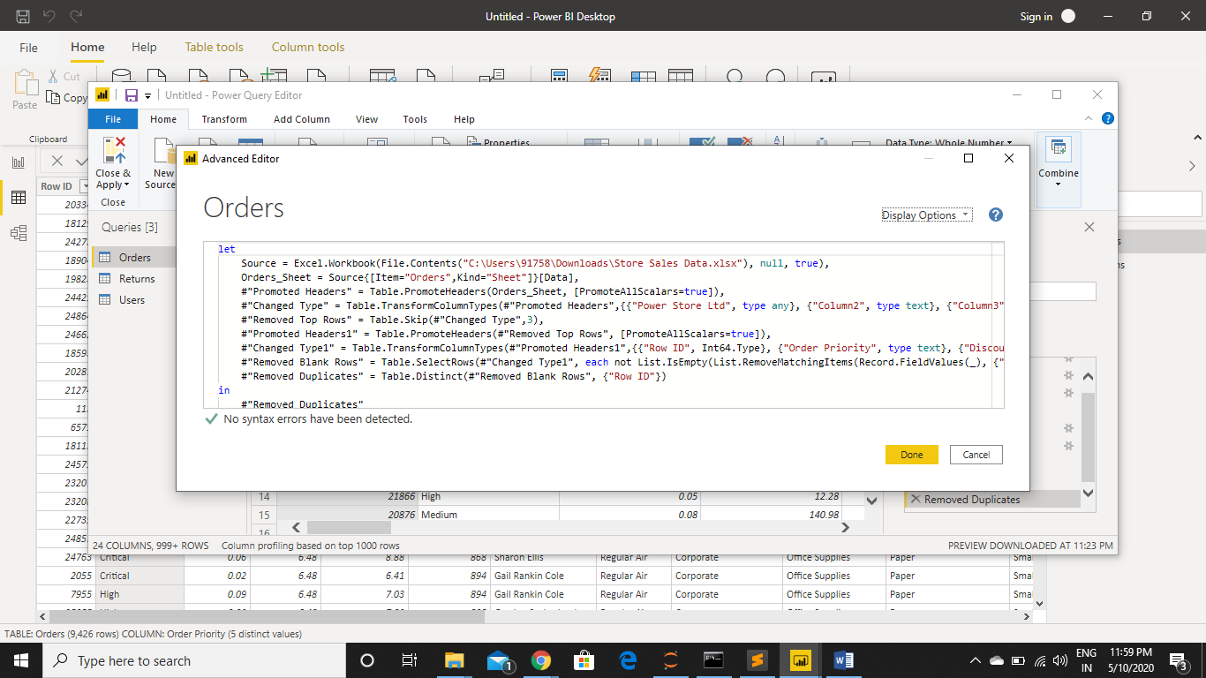

Prepare a document with details of the following along with their price − Power BI Desktop − Power BI Pro − Power BI Premium

**Power BI Desktop**- is where analysts and other users can create data connections, data models and reports. The Power BI service is where those reports can be shared, so other users can view and interact with the reports. Users then query the data to create reports based on their needs. It is free to download and use.

**Power BI Pro** – Self-service and modern BI in the cloud

Collaboration, publishing, sharing, and ad-hoc analysis

Fully managed by Microsoft

₹660 per month per user

**Power BI Premium**- Enterprise BI, big data analytics, cloud and on-premises reporting

Advanced administration and deployment controls

Dedicated cloud compute and storage resources

Allows any user to consume Power BI content

₹330,190 Monthly price per dedicated cloud compute and storage resource with annual subscription